NAME: OLAIYA BISOYE OLORUNFEMI

TRACK: SOFTWARE DEVELOPMENT (PYTHON WEB DEVELOPMENT)

TASK: WEEK 2

DATE OF SUBMISSION: 14th November, 2019

GITLAB USERNAME: bisoyefemi

Project Link: https://gitlab.com/bisoyefemi/bisoye_olaiya.git

**Week 2 task**

Web development Week Two Tasks:

1. Research on css (bootstrap and material design)

2. Research on minimalist Design for web applications

3. Create a simple project called your name (John Doe) on gitlab too

4. Create the index page of the project

5. Create the contact page of the project

6. Create a header and a footer of the project

7. Let the Index page have detailed information about you (it should look more like a profile) page: this page would have your picture, description, hobby, etc -- Be creative

8. Let the contact page have a form with the following fields (Name, email, message) with a submit button

9. Push project to your repository on gitlab and attach the link to your report for the week

**Solution**

1. **What is Bootstrap:** Developed by Mark Otto and Jacob Thornton at Twitter. It was originally named Twitter Blueprint. Bootstrap is an open source CSS Framework which is free and used mainly for responsive mobile-first front end web development applications. CSS is primarily used but HTML based template are also part of it. Asides from CSS and HTML, Bootstrap relies heavily on JavaScript Components mainly in the form of jQuery plugins. Bootstrap is a front-end framework for UIs and themes. Ut specifically used for the client not the server. It designs what the user sees on an application. It is the most popular CSS framework.
2. **What is Material Design:** Developed in 2014 by Google, Material Design is a design language. It is based on card motifs that were first introduced by Google and has expanded including responsive transitions and animations, effects such as lightnings and shadows and grid-based layout. Material Design defines a set of guidelines which showcase how best to design a website. It tells you what buttons are for use and which ones you should use, how to animate or move it, as well as where and how it should be placed, etc. It is a mobile-first design language, which can be used in all of the supported Android versions, thus it provides a consistent and quality experience across all Android applications and platforms, which can also be expanded to other platforms and applications, mainly through APIs for third-party developers. Apart from its ease in implementation and use, another great feature of this designing platform is the lack of dependency on JavaScript frameworks and libraries. Instead, it relies on a material design framework that makes it easier to utilize and provides templates that are customizable and provide a lot of creative freedom, helping to create websites that stand out. Material Design has much more appeal appearance-wise.
3. **Minimalist Design for Web Applications**

The Minimalist website design style often indicates a design approach that UX/UI designers use in trying to simplify their web interfaces and interactions by deleting unnecessary elements. Minimalist websites are usually easy-to-use and offer a better user experience. They webs are simple and responsive. They appear clean and present intuitive interfaces which serves users better. They is known to load faster, which can effectively reduce web bounce rate. The following are design principles to keep in mind when designing a minimalist web application:

1. Use Whitespace to stand out page contents and services.
2. Use Colors wisely to make your web pages attractive.
3. Optimize your website with hierarchical fonts with typography.
4. Explain Page texts with Photos
5. Simplify your website pages with intuitive grids.
6. Never forget to add menus and navigation bars tor better user experience.
7. Simplify your website with Progressive disclosure techniques.
8. Simplify your website with commonly used design strategies
9. Focus on tiny details
10. Never ignore tests
11. **My Profile Project:** I created a project on gitlab as bisoye_olaiya and cloned it to my system. Afterwards, I visited the official website for bootstrap www.getbootstrap.com to download the CSS and JS minified files and then extract it to my project folder/working directory. I created an index.html and contact.html page as directed in the task. I completed the task and pushed my changes to the project repository.

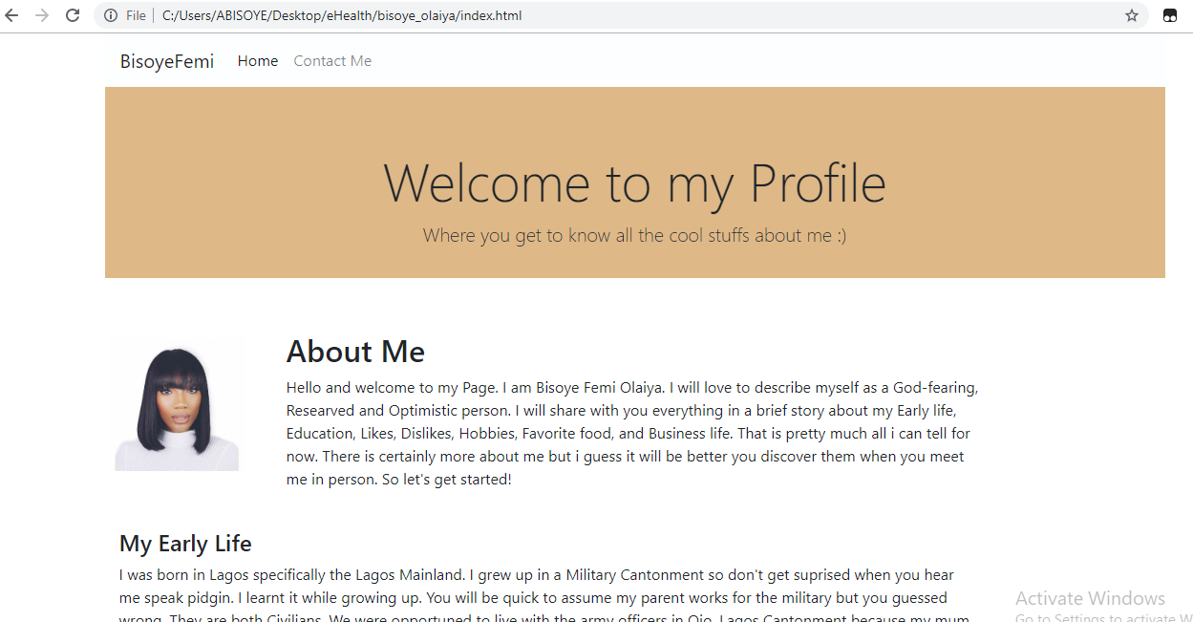

Fig 1: My Index.html page

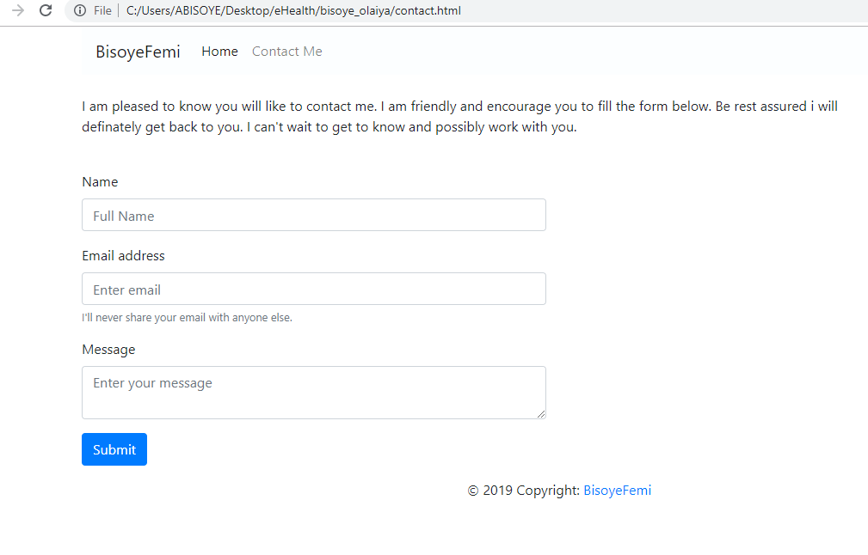

Fig 2: My contact.html page

